**1.Modelo RF5_Indeg Apoio Controlo Diques X All var**.

***Instrucciones modelo***: **test size = 0.31 ; rd_state = 3**

***Variables indep select to fit***:

variables = [

    'id', 'Indeg_RedeRisk_Cen', 'Indeg_RedeConfianc','PC1_Distance_Pro',

'Degree_RedeTotFamil', '1_VarExp_Moranca', '2_VarExp_Atri_Tabanca',

    '5_VarExp_Atri_Idade','9_VarExp_Atri_IndMelhorTecnDiqCint',

    'OutDeg_IntimAmigos_', 'OutDeg_RedeRisk_Cen', 'OutDeg_RedeConfianc']

***Model performance (scores):***

Mean Squared Error: 1.3

R^2 Score: 0.5076 (In Excel: R2 = 0.5275; y = 0.4773 X + 1.4545 )

**Model tot:**

Mean Squared Error (MSE): 0.6744

Root Mean Squared Error (RMSE): 0.8212

Mean Absolute Error (MAE): 0.5349

R^2 Score: 0.7948

Pearson Correlation: 0.9040

***Interactions***:

| **Interacción** | **Importancia** | **Dirección** |
| --- | --- | --- |
| 0 | (Degree_RedeTotFamil, OutDeg_IntimAmigos_) | 0.730004 | 0.073682 |
| 1 | (PC1_Distance_Pro, OutDeg_IntimAmigos_) | 0.667989 | -0.017593 |
| 2 | (9_VarExp_Atri_IndMelhorTecnDiqCint, OutDeg_In... | 0.644580 | 0.019023 |
| 3 | (5_VarExp_Atri_Idade, OutDeg_IntimAmigos_) | 0.644370 | 0.011874 |
| 4 | (OutDeg_IntimAmigos_, OutDeg_RedeRisk_Cen) | 0.642941 | 0.124816 |
| 5 | (1_VarExp_Moranca, OutDeg_IntimAmigos_) | 0.617453 | -0.002763 |
| 6 | (Indeg_RedeConfianc, OutDeg_IntimAmigos_) | 0.599006 | 0.039904 |
| 7 | (2_VarExp_Atri_Tabanca, OutDeg_IntimAmigos_) | 0.598547 | 0.067985 |
| 8 | (Indeg_RedeRisk_Cen, OutDeg_IntimAmigos_) | 0.597560 | -0.003735 |
| 9 | (PC1_Distance_Pro, OutDeg_RedeConfianc) | 0.589277 | -0.021657 |

***Key results****:*

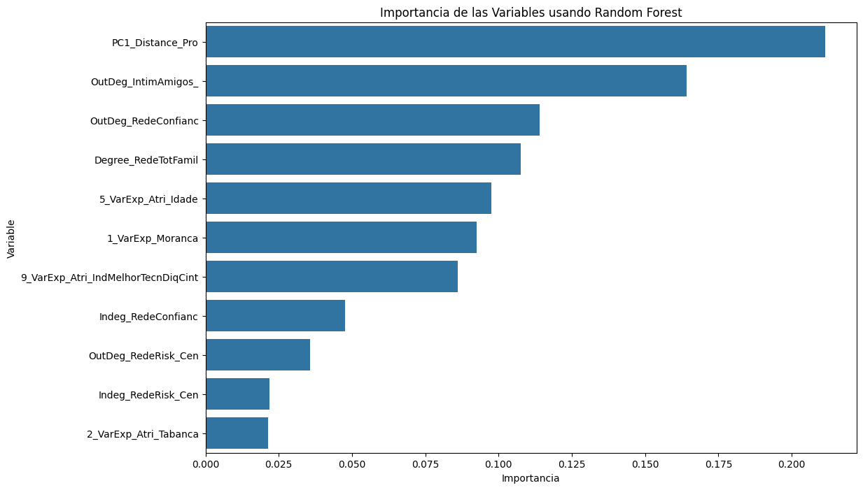

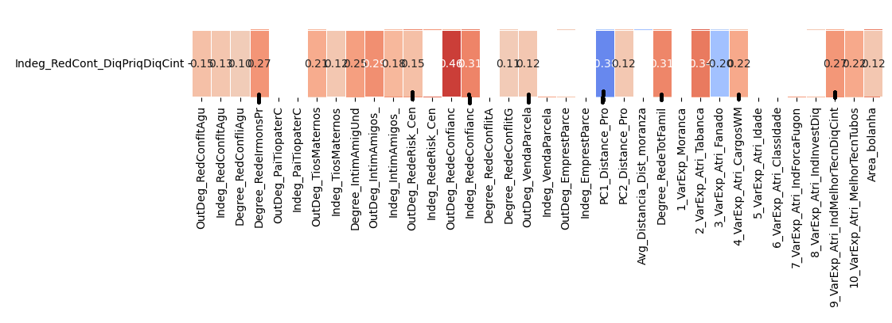

**2.Modelo RF5_Outdeg Apoio Controlo Diques X All var**.

***Instrucciones modelo***: **test size = 0.21 ; rd_state =9**

***Variables indep select to fit***:

variables = ['id', 'Degree_IntimAmigUnd', 'Indeg_RedeConfianc', 'Degree_RedeTotFamil', '9_VarExp_Atri_IndMelhorTecnDiqCint',

'Area_bolanha', 'OutDeg_RedeRisk_Cen']

***Model performance (scores):***

Mean Squared Error: 4.0714

R^2 Score: 0.8381 (In Excel: R2 = 0.8597 ; y = 0.7923 X + 0.1188 )

**Model tot:**

Mean Squared Error (MSE): 1.3101

Root Mean Squared Error (RMSE): 1.1446

Mean Absolute Error (MAE): 0.5659

R^2 Score: 0.8964

Pearson Correlation: 0.9516

***Interactions***:

| **Interacción** | **Importancia** | **Dirección** |
| --- | --- | --- |
| 0 | (Indeg_RedeConfianc, 9_VarExp_Atri_IndMelhorTe... | 2.507652 | 1.015145 |
| 1 | (Indeg_RedeConfianc, OutDeg_RedeRisk_Cen) | 2.330239 | 1.055314 |
| 2 | (Indeg_RedeConfianc, Degree_RedeTotFamil) | 2.302416 | 1.050239 |
| 3 | (Indeg_RedeConfianc, Area_bolanha) | 2.301710 | 1.067860 |
| 4 | (Degree_IntimAmigUnd, Indeg_RedeConfianc) | 2.268476 | 0.000972 |
| 5 | (9_VarExp_Atri_IndMelhorTecnDiqCint, OutDeg_Re... | 1.455842 | 0.272629 |
| 6 | (Degree_IntimAmigUnd, 9_VarExp_Atri_IndMelhorT... | 1.436582 | -0.046575 |
| 7 | (Degree_RedeTotFamil, 9_VarExp_Atri_IndMelhorT... | 1.410904 | 0.002105 |
| 8 | (9_VarExp_Atri_IndMelhorTecnDiqCint, Area_bola... | 1.393346 | 0.271477 |
| 9 | (Degree_IntimAmigUnd, OutDeg_RedeRisk_Cen) | 0.207099 | 0.010112 |

***Key results****:*

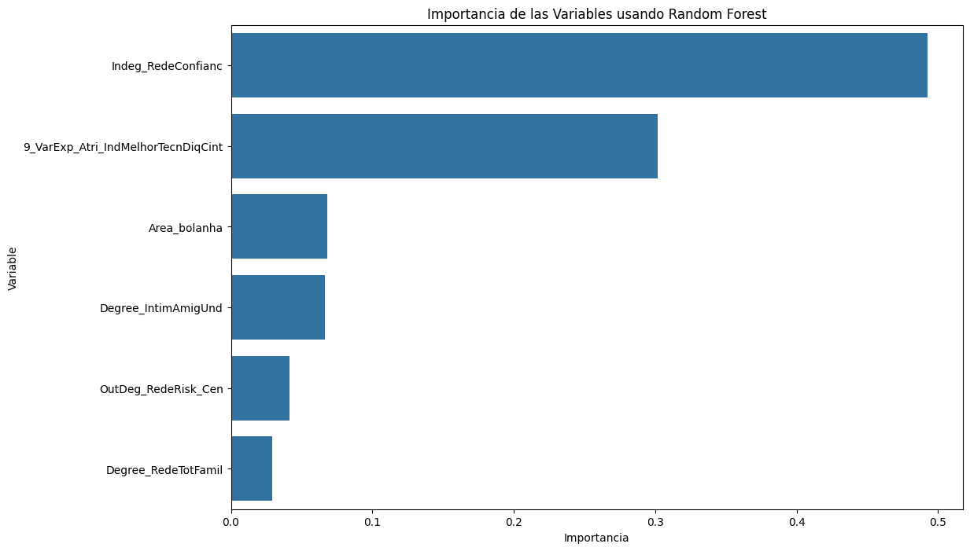

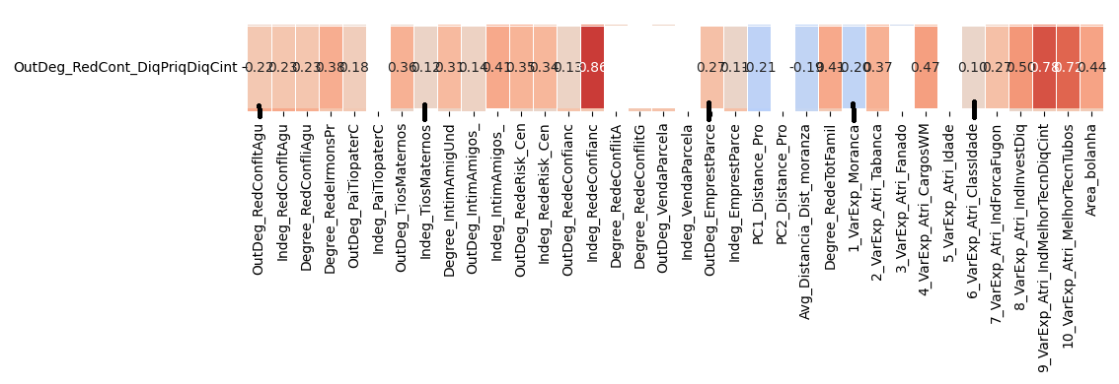

**INTEGRANDO VARIAVEL Melhor técnico tubos**

**2.Modelo RF5_Outdeg Apoio Controlo Diques X All var**.

***Instrucciones modelo***: **test size = 0.27 ; rd_state = 12**

***Variables indep select to fit***:

variables = ['id', 'Degree_IntimAmigUnd', 'Indeg_RedeRisk_Cen',

'Indeg_RedeConfianc','Degree_RedeTotFamil', '9_VarExp_Atri_IndMelhorTecnDiqCint', '10_VarExp_Atri_MelhorTecnTubos'

'1_VarExp_Moranca', 'Area_bolanha','OutDeg_RedeRisk_Cen']

***Model performance (scores):***

Mean Squared Error: 2.1429

R^2 Score: 0.8818 (In Excel: R2 = 0.9222 ; y = 0.7816 X + 0.7018 )

**Model tot:**

Mean Squared Error (MSE): 0.9225

Root Mean Squared Error (RMSE): 0.9605

Mean Absolute Error (MAE): 0.5194

R^2 Score: 0.9271

Pearson Correlation: 0.9738

***Interactions***:

| **Interacción** | **Importancia** | **Dirección** |
| --- | --- | --- |
| 0 | (Indeg_RedeConfianc, 10_VarExp_Atri_MelhorTecn... | 2.591623 | 0.956215 |
| 1 | (Indeg_RedeConfianc, OutDeg_RedeRisk_Cen) | 1.966907 | 0.957644 |
| 2 | (Indeg_RedeConfianc, 1_VarExp_Moranca) | 1.918252 | 0.961634 |
| 3 | (Indeg_RedeConfianc, 9_VarExp_Atri_IndMelhorTe... | 1.901907 | 0.884438 |
| 4 | (Indeg_RedeRisk_Cen, Indeg_RedeConfianc) | 1.887464 | 0.015170 |
| 5 | (Indeg_RedeConfianc, Degree_RedeTotFamil) | 1.884086 | 0.957028 |
| 6 | (Degree_IntimAmigUnd, Indeg_RedeConfianc) | 1.866912 | 0.015944 |
| 7 | (Indeg_RedeConfianc, Area_bolanha) | 1.853616 | 0.952321 |
| 8 | (9_VarExp_Atri_IndMelhorTecnDiqCint, 10_VarExp... | 1.463815 | 0.143082 |
| 9 | (Indeg_RedeRisk_Cen, 10_VarExp_Atri_MelhorTecn... | 1.404618 | 0.016575 |

***Key results****:*

